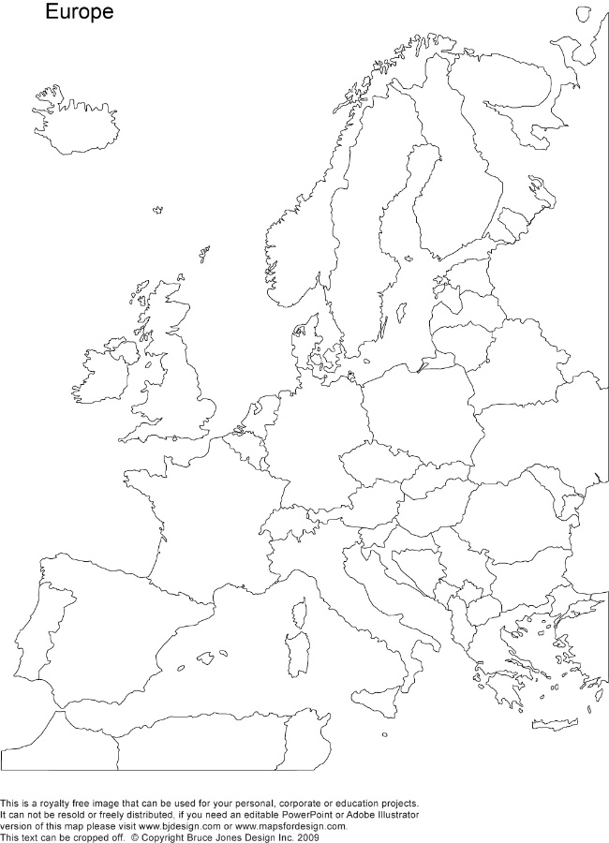

**Western Europe**

*Label the following countries and their capitals:*

Portugal  
Spain  
France  
Iceland  
Ireland  
The United Kingdom  
Germany  
Denmark  
Norway  
Sweden  
Finland  
The Netherlands  
Belgium  
Luxembourg  
Switzerland  
Liechtenstein  
Austria  
Italy

*Label the following bodies of water:*

Atlantic Ocean  
Mediterranean Sea  
The Norwegian Sea

**Western Europe**

*Label the following countries and their capitals:*

Portugal  
Spain  
France  
Iceland  
Ireland  
The United Kingdom  
Germany  
Denmark  
Norway  
Sweden  
Finland  
The Netherlands  
Belgium  
Luxembourg  
Switzerland  
Liechtenstein  
Austria  
Italy

*Label the following bodies of water:*

Atlantic Ocean  
Mediterranean Sea  
The Norwegian Sea